VOIP lab experiment#6
Creating a trunk in PBX

Installation and Repair of Telecommunications Equipment

Name of student:________________
Group Number:_________________
Date:_________________________

The purpose of the lab is to create a trunk in the PBX. A trunk is the phone number of the supplier such as Bell, Videotron, etc…
Go to the trunk, inside of the menu connectivity, and then click on add a sip trunk
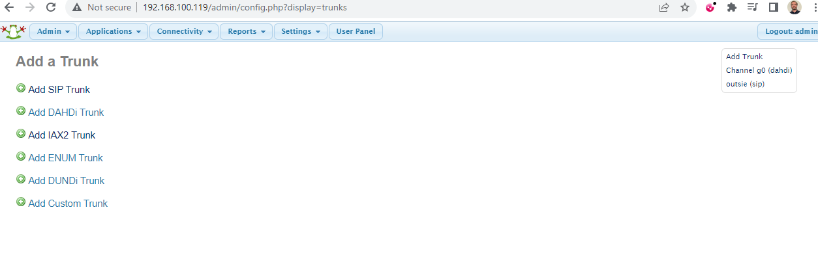

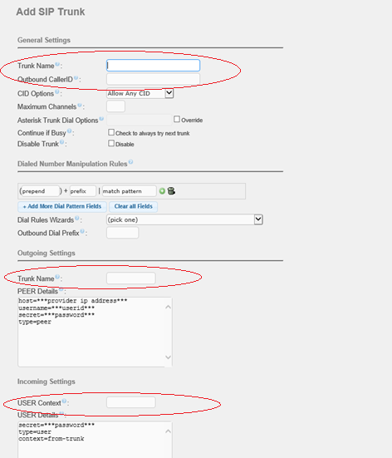
- Enter the following information:
OUTGOING********
host=172.16.0.2
username=51455500xx
fromuser=51455500xx
secret=pec123
type=peer
context=from-trunk
insecure=very
**************

Incoming settings******************
USER CONTEXT 51455500xx
type=peer
secret=pec123
host=172.16.0.2
allow=all
insecure=very
*************************************

Register String:
51455500xx:pec123@172.16.0.2/51455500xx

click on submit and then apply configuration.

